Variables:

* f: The fraction of instructions improved.
* n: The number of small cores in the processor.
* b: The number of big cores in the processor.
* r: How many times larger the area of a big core is compared to a small core.
* s: How many times better the performance of a big core is relative to a small core.
* P: How many times more power a large core consumes relative to a small core.

Equations:

1. Perfhom:s=1/((1-f)+f/n)
2. Perfhom:b=1/((1-f)/s)+(f/s)\*(r/n))
3. Ehom:b=((1-f)/s)\*p+(f/s)\*(r/n)\*(n/r)\*p
4. Perfhet:ms=1/(((1-f)/s)+f/(b\*s+(n-b\*r)))
5. Ehet:ms=((1-f)/s)\*p+ ((b\*p+(n-b\*r))/ (b\*p+(n-b\*r)))\*f
6. Perfhet:ds=1/(((1-f)/s)+f/(n-b\*r))
7. Ehet:ds=(1-f)\*p/s+((n-b\*r)/ (n-b\*r))\*f
8. Perfcom=1/(((1-f)/s)+(f/n))
9. Ecom=r\*(1-f)/s+(f/n)\*n

1)

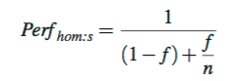

Equation 1 is an optimistic estimation of performance because it does not account for thread parallelization or the overhead of data transfer.

2)

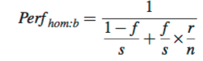

In equation 2, (1-f) is the serial execution fraction of the workload and is speed up by a factor of s, the ‘f’ or parallelized fraction is computed by (n/r) number of big cores.

3)

Macintosh HD:Users:bryanguner:Desktop:Screen Shot 2016-11-13 at 3.35.20 PM.png

During serial execution, the processor consumes p amount of power because only a single core is in use, during parallel execution it consumes p(n/r) assuming all cores are active.

4)

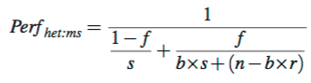

Operating under the assumption of maximum scheduling for the heterogeneous processor where the small cores occupy (n-b\*r) area.

5)

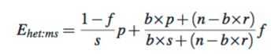

The ‘f’ fraction of the workload is parallelized between both big cores with a speedup of (b\*s) and a small core speed up of (n-b\*r).

6)

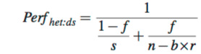

The (1-f) fraction is accelerated by a big core that is ‘s’ times faster than it’s simple counterpart, ‘f’ is parallelized by (n-b\*r) small cores.

7)

Macintosh HD:Users:bryanguner:Desktop:Screen Shot 2016-11-13 at 3.36.12 PM.png

In parallel executions, threads are run exclusively on small cores and consume (n-b\*r) amount of power.

8)

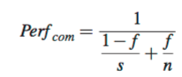

The Composed Processor represents and ideal case where both serial and parallel phases of workload are accelerated in which serial executions are accelerated by a factor of ‘s’ and the ‘f’ fraction of execution is parallelized by ‘n’ small cores.

9)

Macintosh HD:Users:bryanguner:Desktop:Screen Shot 2016-11-13 at 3.37.03 PM.png

The processor dissipates r amount of power during serial execution and n amount of power during parallel execution.

10.)

s α √(r) ;(where alpha‘α’means is correlated to)

Microprocessor performance increase due to microarchitecture advances is roughly proportional to the square root of the proportion by which the area of a large core is greater than that of a small core.